|  |  |  |  |  |  |
| --- | --- | --- | --- | --- | --- |
| Date | 2-Dec-22 | | | Tester Name | Andrew McLaughlin |
| Environment | Penfax - Test | | | Login used |  |
| Operating System | Select OS | Version: | Update: | | |
| Software Used | Select Software | Version: | Update: | | |
| Select Software | Version: | Update: | | |
| Release version | 22.4.1 | | | | |
| Title | General member eligible to retire with excess | | | | |
| Test Type | Regression | | | | |
| Test Scenario | General member eligible to retire with excess | | | | |
|  |  | | | | |
| Expected Results |  | | | | |
| Pass/Fail | Pass | | | JIRA# | N/A |

Describe your steps with screenshots:

Member deferred and Calculated Service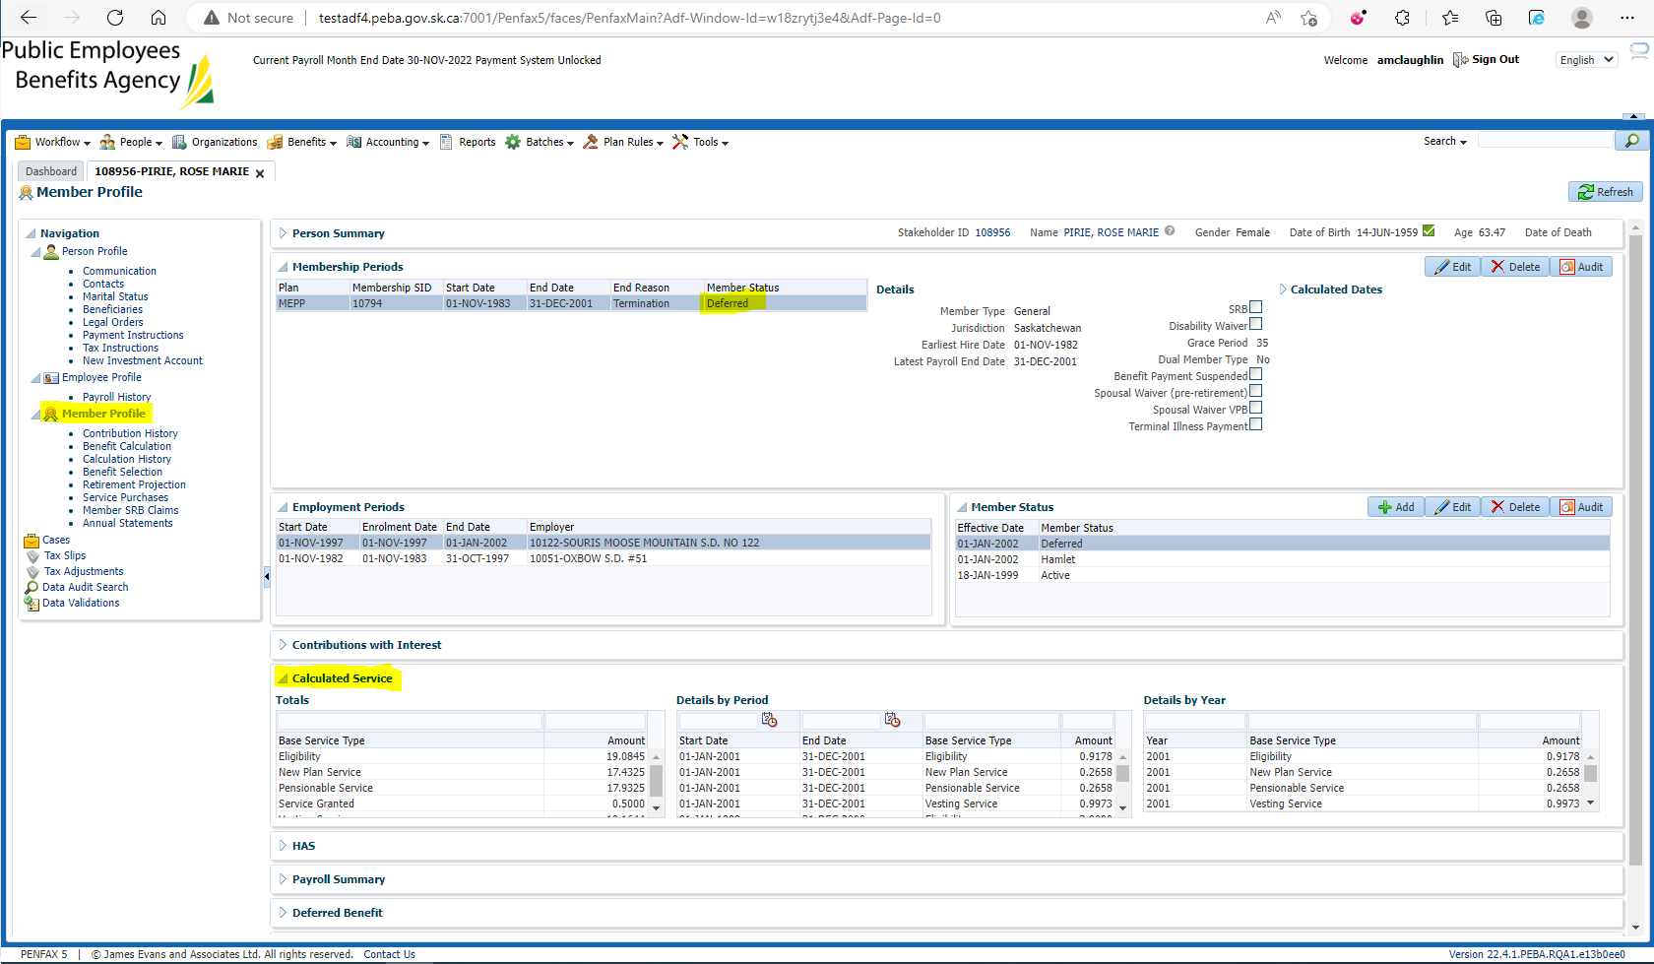

Ensure the Grace Period under Member Profile is long enough to let them select their Benefit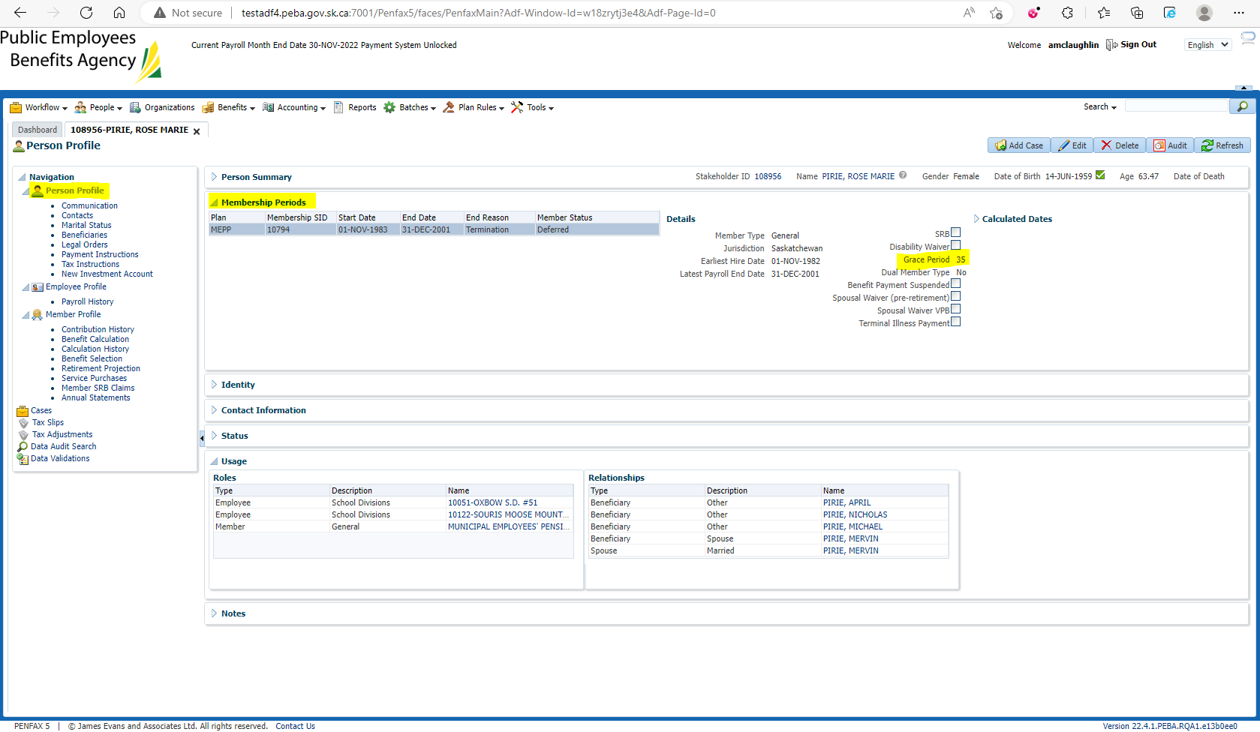

Go to Benefit Selection -> Next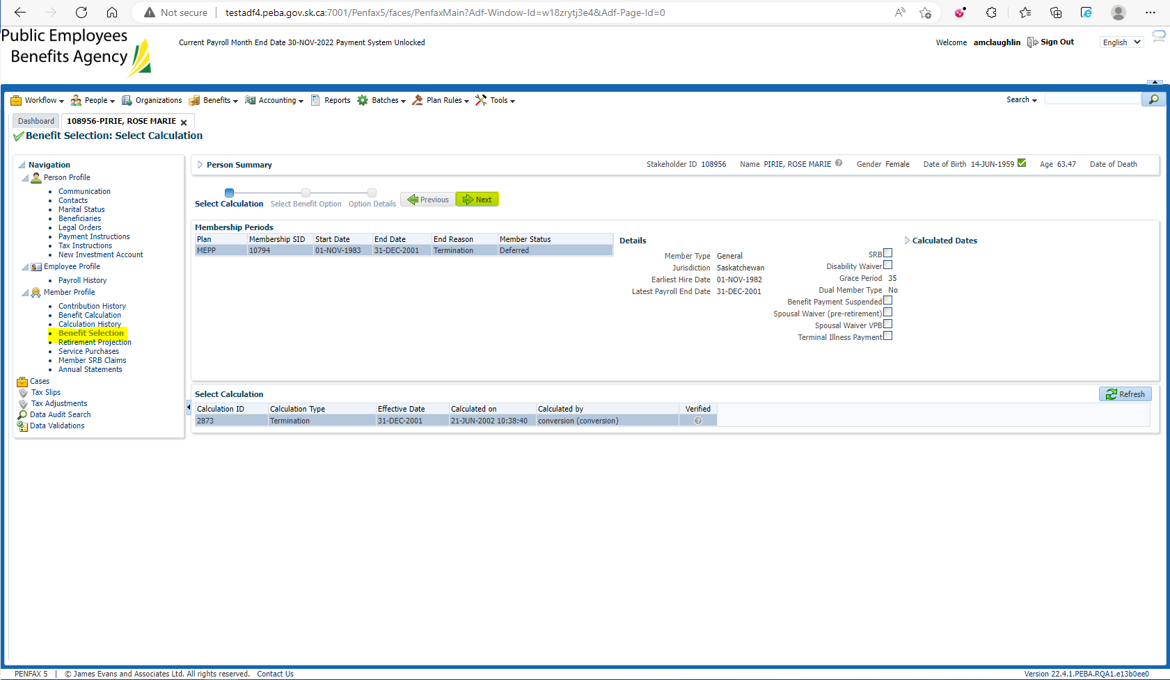

Note the excess, add payment date, Next 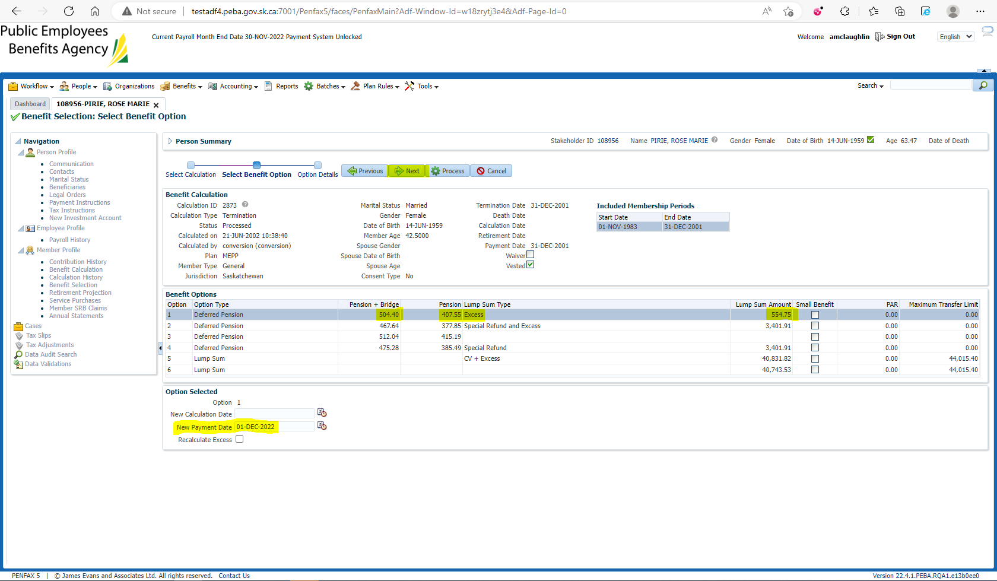

Note start date, add payment instruction, Process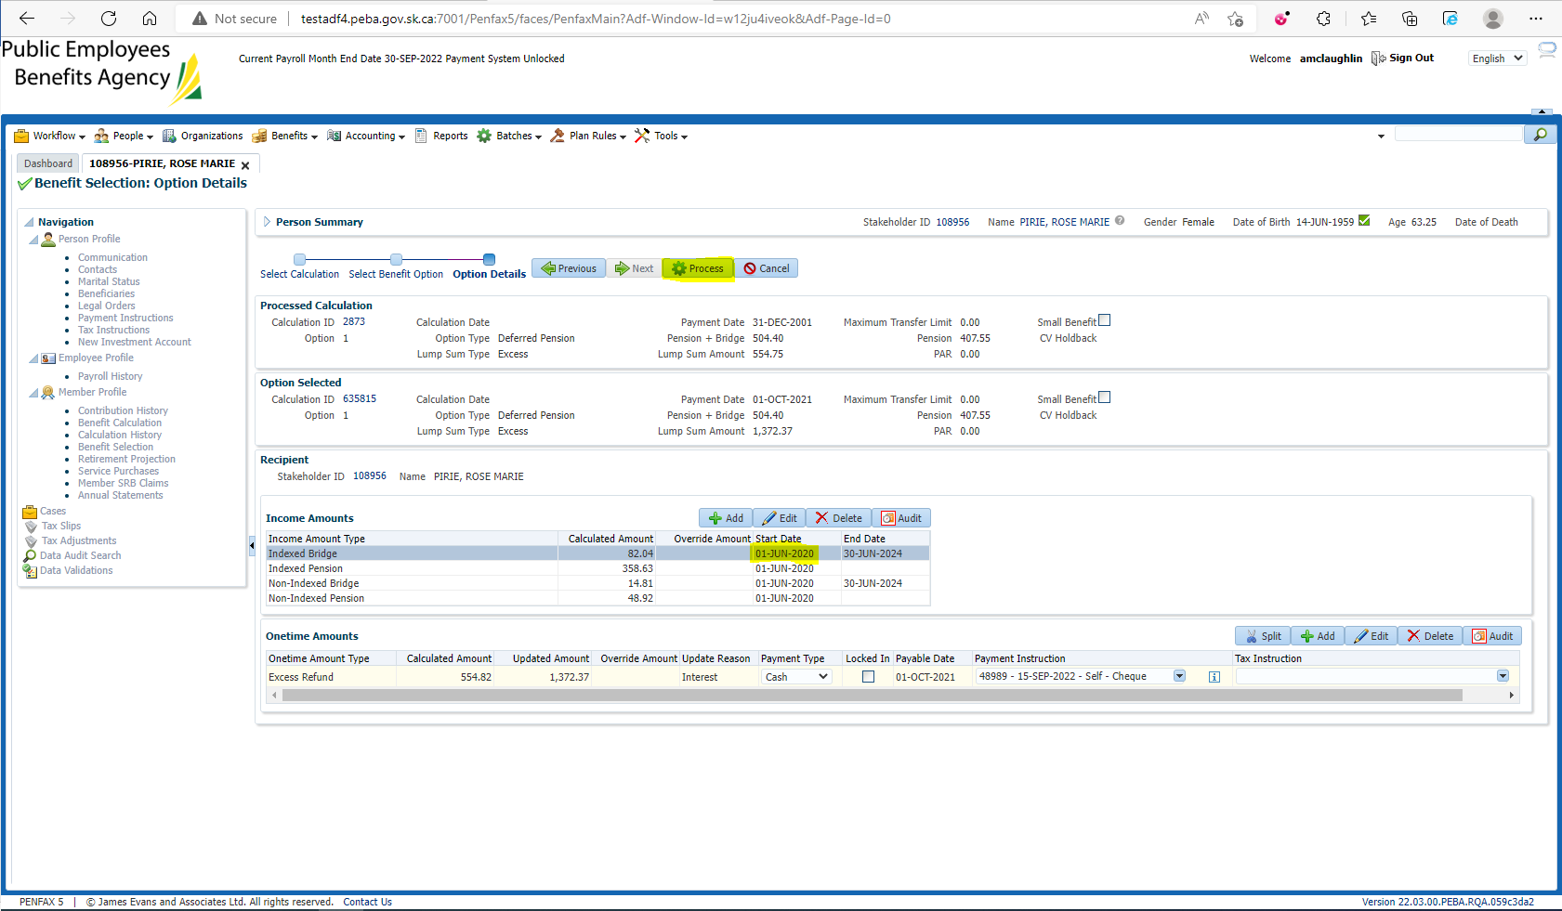

Confirm the Excess has been set up to be paid out. After the Excess has been paid out, the Benefit Calc/Selection can be run for retirement 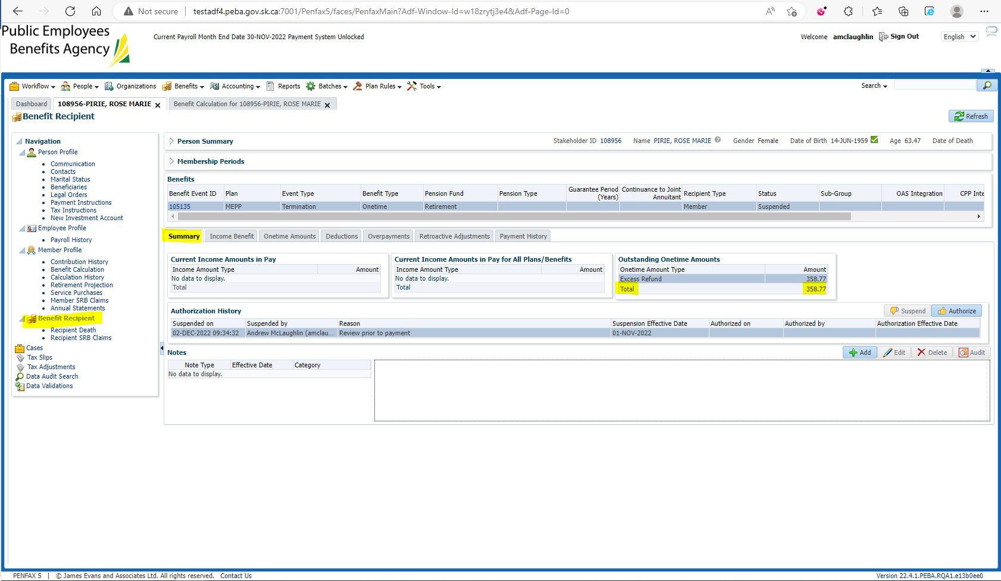

In the Benefit Calculation, set the retirement date for the 1st of the next month and hit Calculate 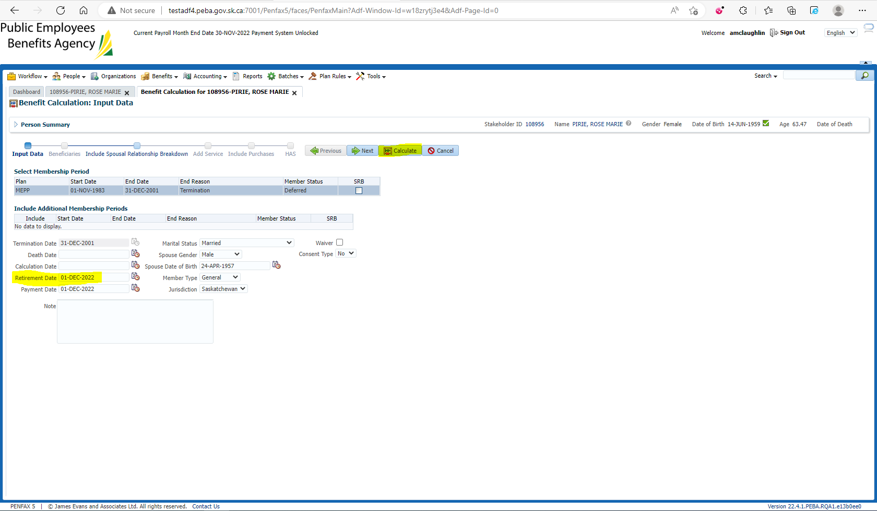

Process the Benefit Calc 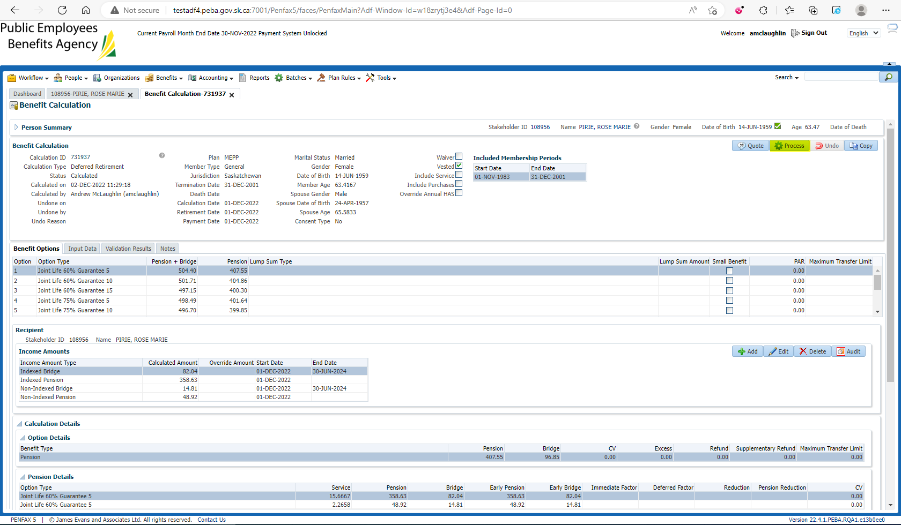

Go to Benefit Selection and hit Next 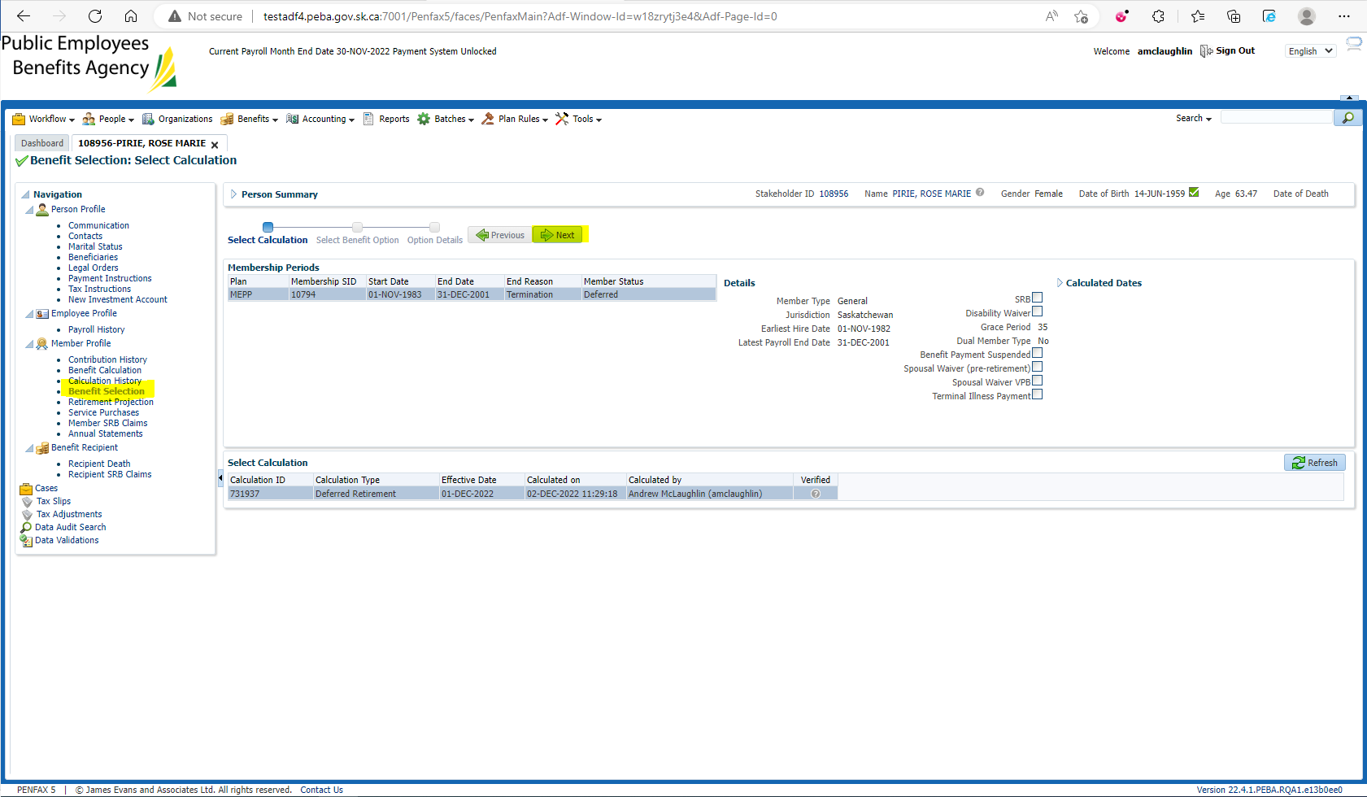

Enter the New Payment Date and hit Next 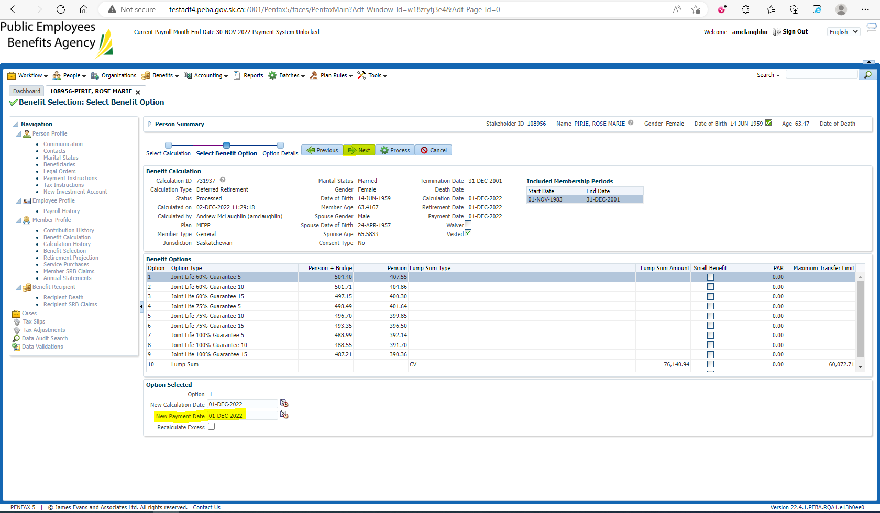

Select a Payment Instruction and Process 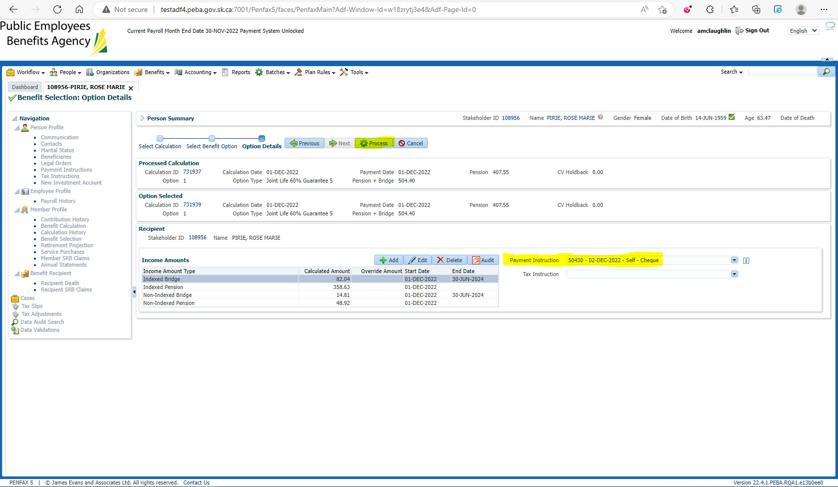

Member status is now Pensioned and Calculated Service matches 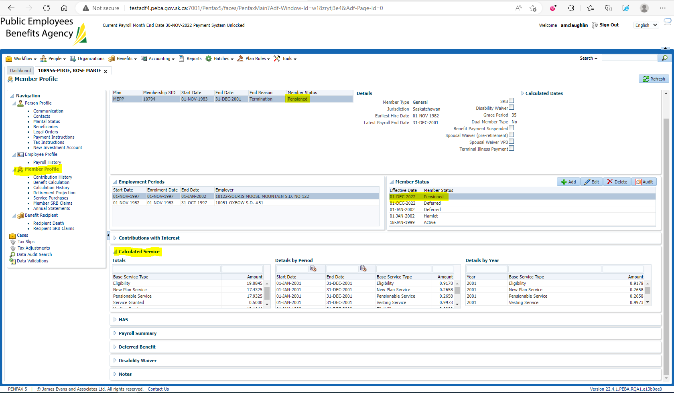

Training/Production Data matches 